Stolen Lives Autumn/Winter 2024 Update
With thanks to the Stolen Lives Team: Janis Griffiths, Professor David Abbott, Joe Powell and Doctor Dawn Cavanagh.

Here is an update of what the SL Team have been up to:

Presenting at Conferences:
3rd October-Janis and Dawn presented on behalf of Stolen Lives at the 2nd Carers Assembly in Cardiff organised by Voices Adfocad.

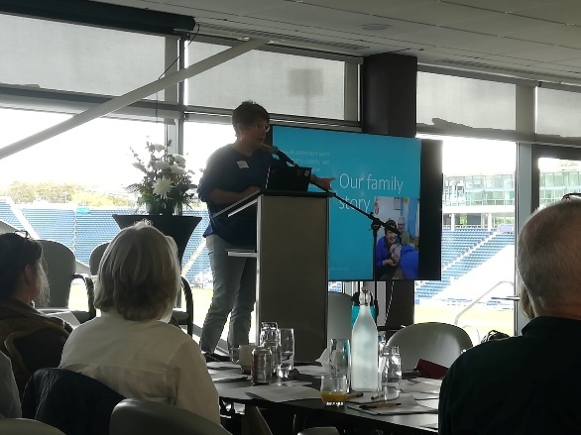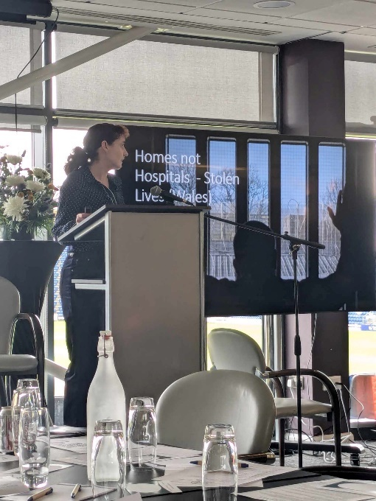

Meeting with the Minister:
8th October-The Stolen Lives Team met with the Minister for Mental Health and Wellbeing, Sarah Murphy, for an online meeting.
SM gave assurances that the issues raised by SL will be a WG priority.

Task and Finish Group
The Stolen Lives, Homes not Hospitals, is a sub-group of the Learning Disability Ministerial Advisory Group.
Stolen Lives have attended two Task and Finish Group meetings so far: on 15th October and 2nd December.
The purpose of the group is to provide the Minister for Mental Health and Wellbeing with advice and recommendations for action on how Welsh Government can address the concerns and issues raised by the Stolen Lives, Homes not Hospitals, Campaign.

Awards:
31st October-Stolen Lives was awarded the Understanding Disabilities Committee Award at the Cardiff and Vale Parents Federation Award Ceremony, Cardiff Bay.

28th November-Stolen Lives won the Outstanding Contribution to Restraint Reduction (Lived Experience Award) at the Restraint Reduction Network Conference, Newcastle.

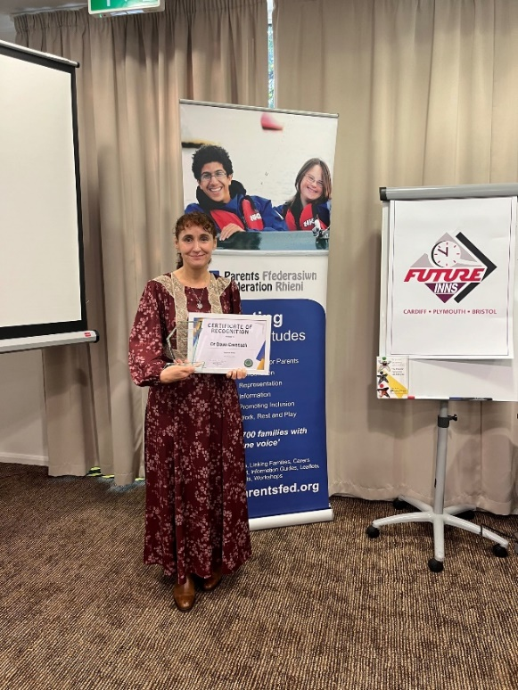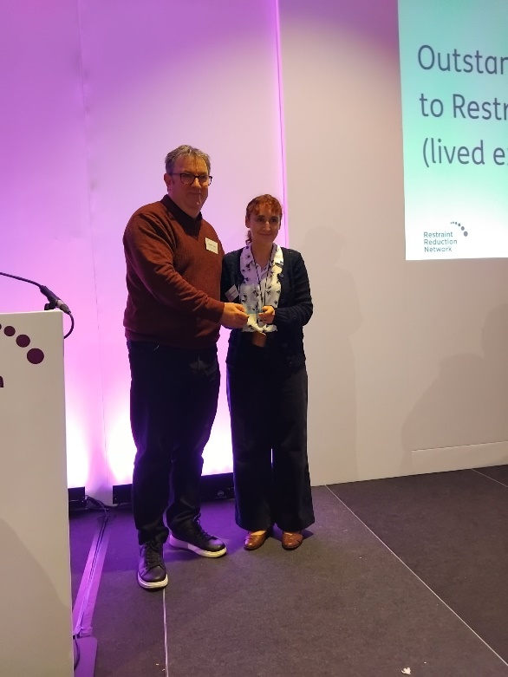

Senedd Stolen Lives Debate

December 4th-The Stolen Lives motion was passed unanimously in the Senedd. This is a significant step forward in our Homes not Hospitals campaign for people with learning disabilities and autistic people.
Thank you so much to Hefin David MS for leading the debate, and Sioned Williams MS and Mark Isherwood MS for supporting it.

Thank you to Learning Disability Wales and All Wales People First for your support at the Senedd.

At last, the inhumane hospitalisation of our loved ones has been acknowledged by the Welsh Government as the human rights injustice it is and as the minister said one person locked up is one too many.

To the Stolen Lives families, we keep fighting!

You can watch the debate here (start time: 3.55)

Senedd.tv - Plenary - 04/12/2024

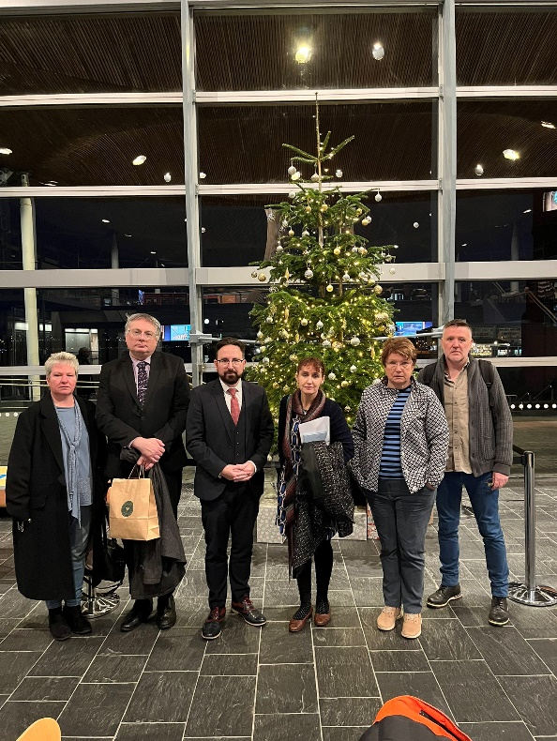
Press covering the debate:

Autistic man spent two years living 100 miles from home in 'effectively a prison' - Wales Online

Senedd supports calls to end autism human rights scandal | Western Telegraph

Cross-Party Autism Group

12th December-Dawn gave an update to the Cross-Party Autism Group on the SL campaign.

Petition
A positive response was received from the Petitions Committee.
You can view the response here (item 3:5)

Minutes:
The Committee considered the petition and congratulated the petitioners for their persistence in engaging with the Welsh Government and individual Senedd Members on this critical issue.

It was noted that Hefin David MS would be holding a Member debate on Wednesday 4 December under Standing Order 11.21(iv) - Care settings for autism and learning disability. The Chair agreed to contribute to the debate by highlighting the petition.

The Committee agreed to share the petitioners’ comments with the Minister and seek a response to the questions raised including;

- clarifying how Welsh Government will involve the campaigners after the Task and Finish Group reports;
- what progress is being made to address the data issues;
- the need for a communications plan to better understand what progress is being made; and
- a response to points made about the impact of the closure of inpatient services and reform of the Mental Health Act.

In doing so the Committee agreed to copy the correspondence to the Chair of the Health and Social Care Committee and the Senedd’s Learning Disability Cross-Party Group for awareness.

You can view the documentation in full here (item 3:5)
Agenda for Petitions Committee on Monday, 2 December 2024, 14.00

D. Cavanagh, 19 December, 202

