September 25th 2025

Stolen Lives attended the Good Life Alliance Homes Not Hospitals: Why We Must Do This - and How It Is Being Done event at the Senedd in Cardiff. The Good Life Alliance are a Wales-based alliance of individuals and organisations with three aims:

Bringing people back home from long-term placements in hospitals and other institutions.

Improving local services to prevent people from being sent away in the first place.
- Promoting people’s right to choice and control over their life, accommodation and support.
Stolen Lives are a member of the Good Life Alliance. You can read more about the Good Life Alliance here: https://goodlife.wales
The panel together with Sioned Williams MS and Mark Isherwood MS paid tribute to Hefin David MS and pledged to continue Hefin's legacy though the much-needed work the Stolen Lives campaign have brought to the forefront with the Homes not Hospital Campaign, which Hefin actively supported. We miss you Hefin.

There were powerful testimonies from families. Kate Scott, Behavioural Team Leader of Hywel Dda Health Board, spoke with Dawn about the wonderful work she and ‘Team J’ did to help get Dawn’s son out of hospital and into his own home.

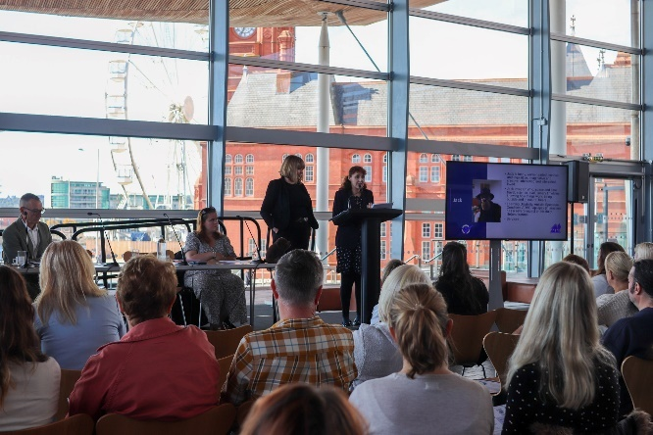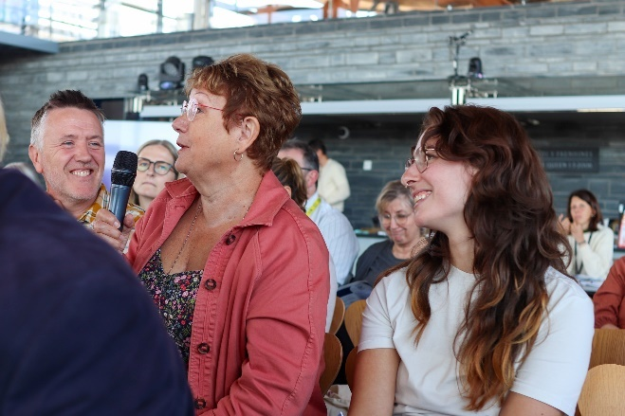
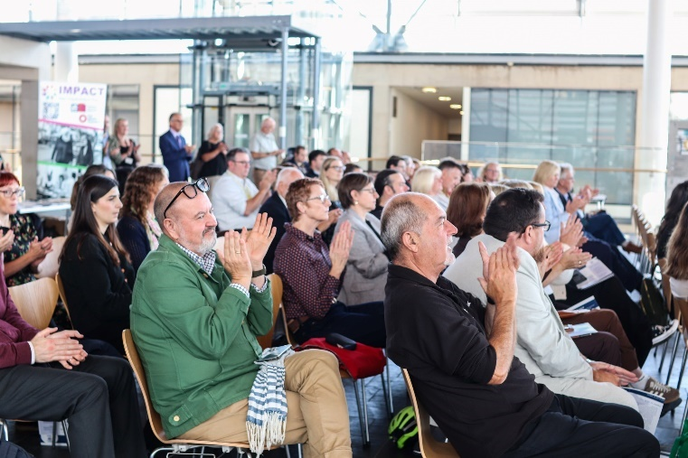
November 6th and November 13th
Joe attended the Learning Disability Wales National Conference 2025 My Home Matters in Conwy and Swansea, representing All Wales People First and Stolen Lives.
Joe delivered a super workshop on the work of Stolen Lives and the Learning Disability Ministerial Advisory Group on Homes not Hospitals. Joe also paid tribute to the late Hefin David MS for the wonderful support and impact he had on the Stolen Lives campaign.

Thank you, Joe.

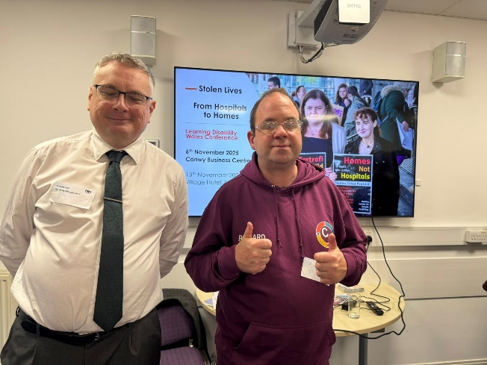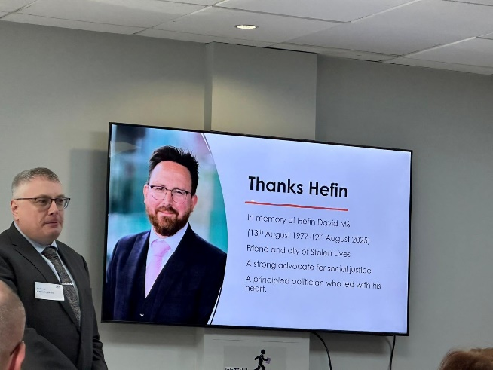

December 2025

Our lovely Joe has sadly had to leave Stolen Lives. We would like to thank Joe for his wonderful support and we look forward to working with him in the future in his role as Chief Executive of All Wales People First.

